

Copyright Transfer and Declaration

- I hereby transfer the Copyright of the title: WEB BASED HOSPITAL MANAGEMENT SYSTEM

By (Authors): M.HARI MURARI, R.ROHINI, R.VIKITHA

Full Postal address of Principal Author (With phone no. and mail id):
YAMNAMPET, GHATKESAR, HYDERABAD, TELANGANA, INDIA-501301
PH NO-9390565052
EMAIL: 23315a0527@cse.sreenidhi.edu.in

- I understand that the Editor-in-Chief-IRE may transfer the Copyright to a publisher at his discretion.

- The author(s) reserve(s) all proprietary rights such as patent rights and the right to use all or part of the article in future works of their own such as lectures, press releases, and reviews of textbooks. In the case of republication of the whole, part, or parts thereof, in periodicals or reprint publications by a third party, written permission must be obtained from the Editor-in-Chief IRE.
- I hereby declare that the material being presented by me in this paper is our original work, and does not contain or include material taken from other copyrighted sources. Wherever such material has been included, it has been indented or/and identified by quotation marks and due and proper acknowledgments given by citing the source at appropriate places.
- The paper, the final version of which I enclose, is not substantially the same as any that I/we have already published elsewhere.
- I/we have not sent the paper or any paper substantially the same as the enclosed one, for publication anywhere else.
- Furthermore, the author may only post his/her version provided acknowledgment is given to the original source of publication and a link is inserted to the published article on the IRE website.
- The submitted/enclosed camera-ready paper is thoroughly proofread by me and in conformity with the instructions for authors communicated to me.
- If any plagiarism is found in my camera-ready paper after Publication, I am the whole responsible not IRE or IRE Board members.

Author Signature | 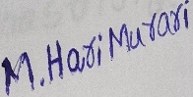 | 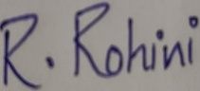 | 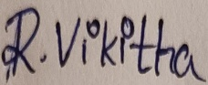
Author’s Name (in Block letters) | M.HARI MURARI | R.ROHINI | R.VIKITHA

DATE:13/04/2026
PLACE: HYDERABAD
- Kindly send a scanned copy of the completed and duly signed form by email to the Editor-in-Chief at irejournals@gmail.com.

